AGRI-QUEST: (in four sentences, and our Logo)

Strengthening Agribusiness Ethics, Quality Standards and ICT usage in Uganda’s value chains” (AGRI-QUEST) is a three year’s research funded with 300,000 Euros by Netherlands Ministry of Foreign Affairs through NWO-WOTRO. MUBS is the lead research institution. The research was started to find answers to one central question: How can we have a better business climate that fosters a permanent and positive gradual change in practices, attitudes in agribusiness towards ethical behavior, quality standards in food security and agri-business initiatives?
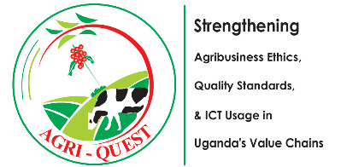

Brief details about AGRI-QUEST:
Background: Despite the benefits enshrined in embracing (i) ethical and (ii) quality issues with respect to accelerating transformation, competitiveness and sustainability of a vibrant food security program and a vibrant food game (Lucas Simons, 2014), there is a considerable lack of attention to these two issues in agribusiness value chains in Uganda. This henceforth raises a question: How can we have a better business climate that fosters a permanent or positive gradual change in practice & attitude towards agribusiness ethical behavior and quality standards in food security initiatives?
Objective: The main objectives of the project are:
- Establish alternative ways of encouraging beneficiaries of agricultural development supported initiatives to engage in dialogue about introducing ethical agricultural standards.
- Develop and disseminate resources necessary to make informed ethical and quality standard-based decisions in support of a more just and equitable food and agriculture VC system.
- Ascertain how decision-making procedures in international food and agriculture policy and practices can be implemented by agricultural players at the bottom of the pyramid.
- Assist agricultural VC micro-players to adhere to basic Codes of Conduct.
- Review existing agribusiness quality standards, ethical dilemmas, & mobile ICT applications (mobile apps) to determine their appropriateness in sustaining a competitive agribusiness climate.
- Develop a website and mobile app which can be used as (1) reference point for agricultural standards and ethical practices; and (2) a “farmer-to-buyer” brokerage and market information access point.
Research methodology: AGRI-QUEST uses these engagement processes: capacity building of farmers/value chain players, wide consultations & stakeholder engagement to ensure buy-in, uptake of research outcomes and knowledge exchanges.

AGRI-QUEST Implementing partners:
- Makerere University Business School (MUBS); VU Universteit Amsterdam; The Ssemwanga Center for Food and Agriculture Ltd., and Kibeedi & Co. Advocates

